|  |  |
| --- | --- |
| **Ex. No. 5** | **JAVASCRIPT – DOM ELEMENTS AND EVENTS** |
| **Date of Exercise** | 30/1/2022 |

**Aim**

To create a webpage that demonstrates dynamic actions for user interactions using javaScript object model events.

**Description**

**Document object Model:**

Represents the HTML document that is displayed * Has various properties which to objects that allows to and access modification of document content. It is called Dom

Finding HTML elements:

By ld: document.getElementById("<id>");

By Tag Name: document.getElementsByTagName("<tagname>);

By class Name: document.getElementsbyclassName("<class_name>");

By css selectors: document.querySelectorall("<selector>");

Javascripts interaction with HTML is handled through many events some of them were as follows:

* occus when the user (s) browser manipulate it.
* onload : triggered while document loads
* onclick: triggers on a mouse click Triggers when an element changes.
* onkeyup: Triggers when a key is released
* onkey down: Triggers when a key is pressed.
* onsubmit: Triggers when a form is submitted
* onmouseover: Triggers when a mouse pointer over it.
* onmousedown. Triggers when a mouse button is pressed.

**Program**

1.

<!DOCTYPE html>

<html lang="en">

<head>

<meta charset="UTF-8">

<meta http-equiv="X-UA-Compatible" content="IE=edge">

<meta name="viewport" content="width=device-width, initial-scale=1.0">

<title>Simple Calculator</title>

<link rel="stylesheet" href="simple_calculator.css">

<script>

function operations(operator) {

var operand1 = document.getElementById("num1").value

var operand2 = document.getElementById("num2").value

var results = eval(parseInt(operand1) + operator + parseInt(operand2))

document.getElementById("results_div").innerHTML = "Results: " + results

}

function reset() {

document.getElementById("results_div").innerHTML = "Results: "

}

</script>

</head>

<body>

<div id="content">

<h1>Basic Calculator</h1>

<input type="text" id="num1" name="number1" placeholder="Number1 Eg. 1015">

<input type="text" id="num2" name="number2" placeholder="Number2 Eg. 1016"><br>

<button onclick="operations('+')">Add</button>

<button onclick="operations('-')">Subtract</button>

<button onclick="operations('*')">Multiply</button>

<button onclick="operations('/')">Divide</button><br>

<div id="results_div">Results: </div>

<button onclick="reset()" id="clear_btn">Clear</button>

</div>

</body>

</html>

body {

background-color: grey;

}

#content {

display: inline-block;

background-color: lightskyblue;

padding: 1%;

width: 40%;

height: 40%;

margin-top: 12%;

margin-bottom: 12%;

margin-left: 29%;

margin-right: 29%;

}

h1 {

text-align: center;

font-family: Arial, Helvetica, sans-serif;

}

input {

padding: 1%;

font-size: medium;

font-family: 'Gill Sans', 'Gill Sans MT', 'Trebuchet MS', sans-serif;

width: 46%;

border: 2px solid darkslateblue;

}

button {

width: 20%;

color: white;

background-color: blue;

padding: 1%;

margin: 2%;

margin-top: 8%;

margin-bottom: 1%;

}

#results_div {

display: inline-block;

width: 68%;

border: 2px solid black;

padding: 2%;

font-size: medium;

font-family: Georgia, Times, 'Times New Roman', serif;

}

#clear_btn {

background-color: red;

}

2.

<!DOCTYPE html>

<html lang="en">

<head>

<meta charset="UTF-8">

<meta http-equiv="X-UA-Compatible" content="IE=edge">

<meta name="viewport" content="width=device-width, initial-scale=1.0">

<title>BMI Calculator</title>

<link rel="stylesheet" href="bmi_calculator.css">

<script>

function calculator() {

var w = parseInt(document.getElementById("weight").value)

var h = parseInt(document.getElementById("height").value)

var bmi = (w / ((h / 100) * (h / 100)))

var BMI = bmi.toFixed(1)

document.getElementById("res").innerHTML = BMI

if (BMI < 18.0) {

document.getElementById("results_div").innerHTML = "Underweight BMI"

} else if (BMI > 18.0 && BMI < 25) {

document.getElementById("results_div").innerHTML = "Normal BMI"

} else if (BMI > 25 && BMI < 30.0) {

document.getElementById("results_div").innerHTML = "Overweight BMI"

} else if (BMI > 30.0) {

document.getElementById("results_div").innerHTML = "Obese BMI"

}

}

</script>

</head>

<body>

<div id="outer">

<div id="header">

<span>Body Mass Index (BMI)</span> <br> A measure of body fat in adults

</div>

<div>

<div id="inputs">

<label for="weight">Weight (in kg)</label><br>

<input type="text" name="weigh" id="weight" onkeyup="calculator()">

<br>

<label for="height">Height (in cm)</label><br>

<input type="text" name="heigh" id="height" onkeyup="calculator()">

</div>

<div id="results">

<p id="res">0.0</p>

<div id="results_div">Your BMI Displays here</div>

</div>

</div>

</div>

</body>

</html>

#outer {

border: 2px solid black;

display: inline-block;

width: 32%;

height: 40%;

}

#header {

padding: 1%;

background-color: lightgreen;

}

#header span {

font-weight: bold;

}

#inputs {

display: inline-block;

padding: 1%;

}

input {

margin: 2%;

padding: 2%;

text-align: center;

}#results p {

font-size: 40px;

text-align: center;

font-weight: bolder;

color: blue;

margin-top: 1%;

margin-bottom: 1%;

}

#results_div {

text-align: center;

}

**Output**

**1.**

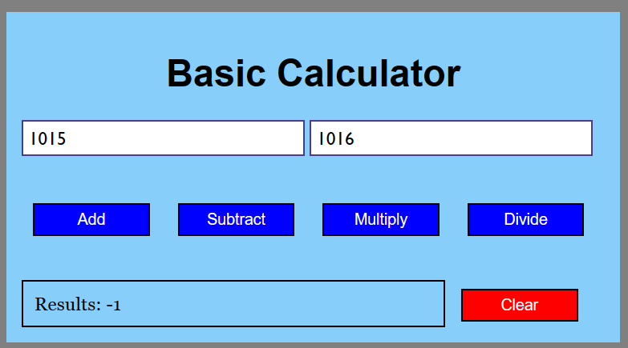

**2.**

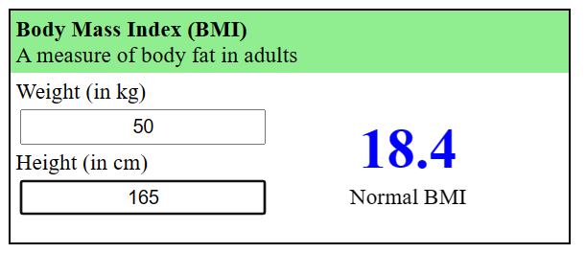

**Result**

The webpage that demonstrates dynamic actions for user interactions using javaScript object models events has been executed successfully and the desired output is displayed on the screen.